Week1
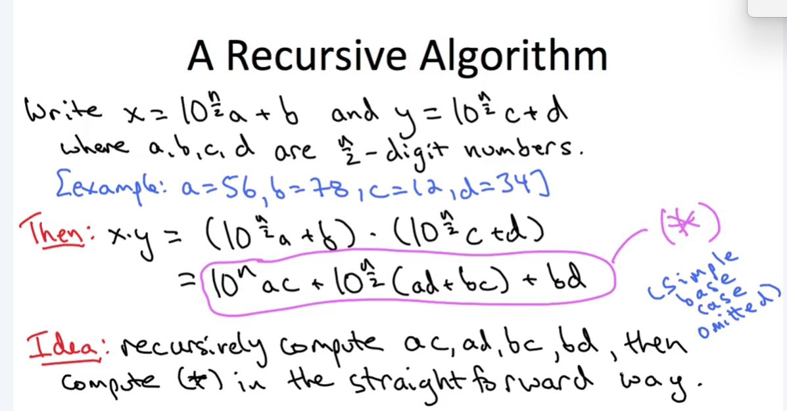
Karatsuba Multiplication

